Setting Up a Local LLM Written Directions:
*We will be working in Git:Hub Code spaces because we can not set up Ollama on school computers. If you decide to replicate this at home, you should create a project folder and go to step 2.*
- Create a GitHub repo for this project:
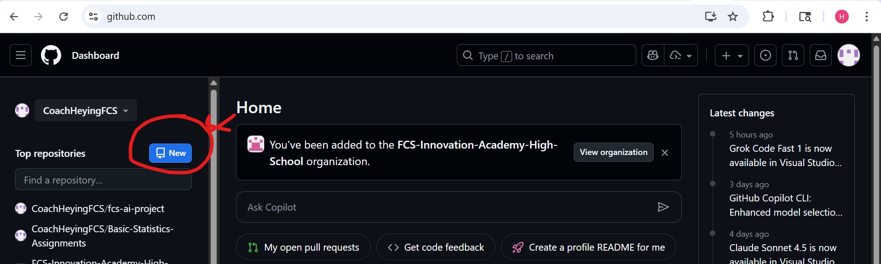
  - Name it something like: ollama-test
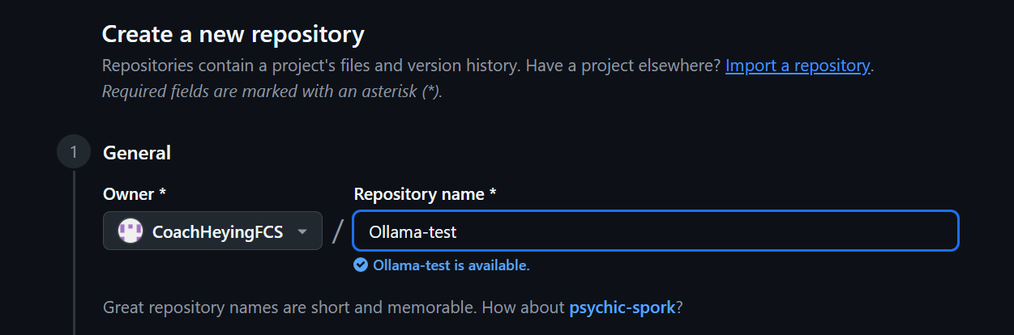
- Create a Modelfile for the root
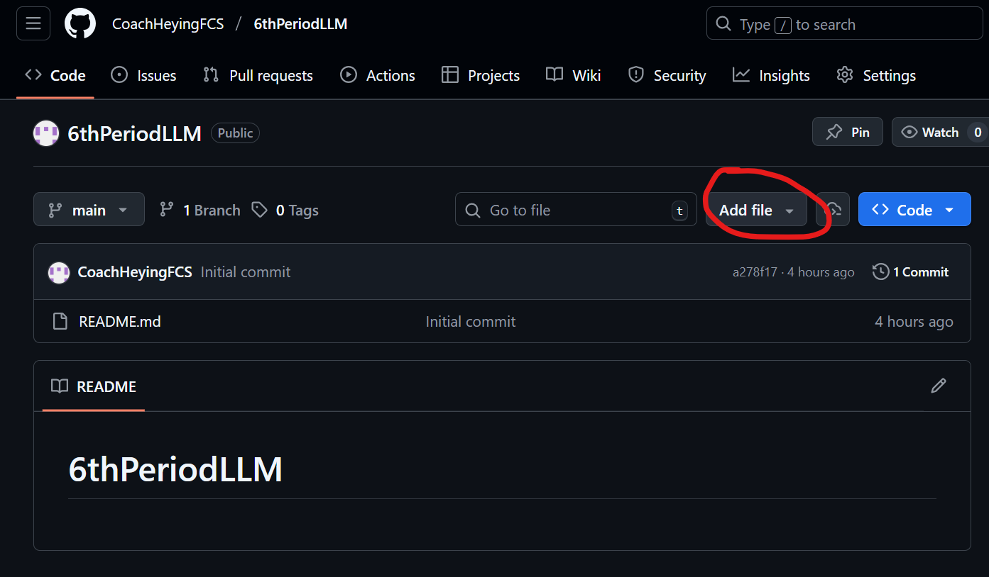
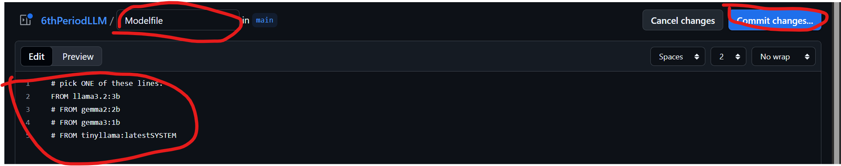
# pick ONE of these lines:
FROM llama3.2:3b
# FROM gemma2:2b
# FROM gemma3:1b
# FROM tinyllama:latestSYSTEM Open up a Codespace
- Open the Project in Codespaces:
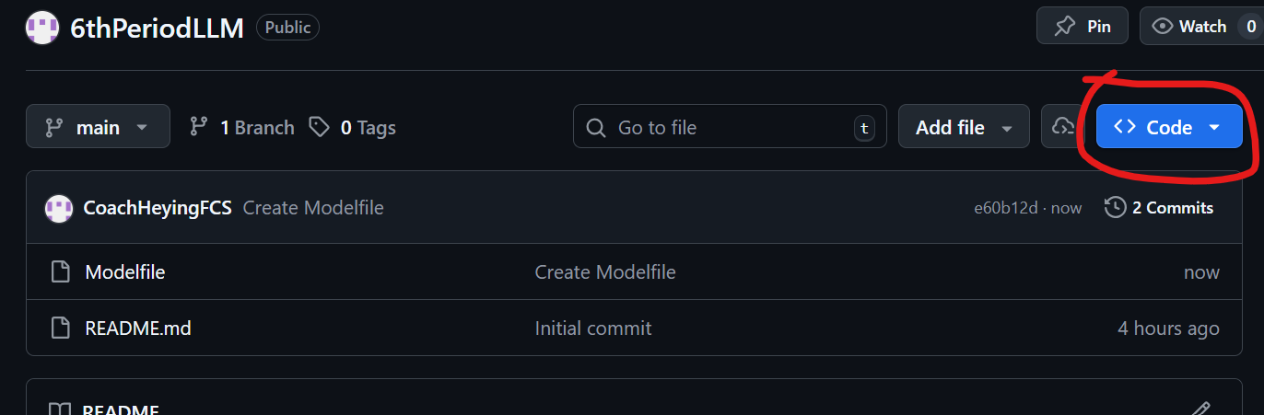
- Install Ollama in the terminal:
  - curl -fsSL https://ollama.com/install.sh | sh
  - 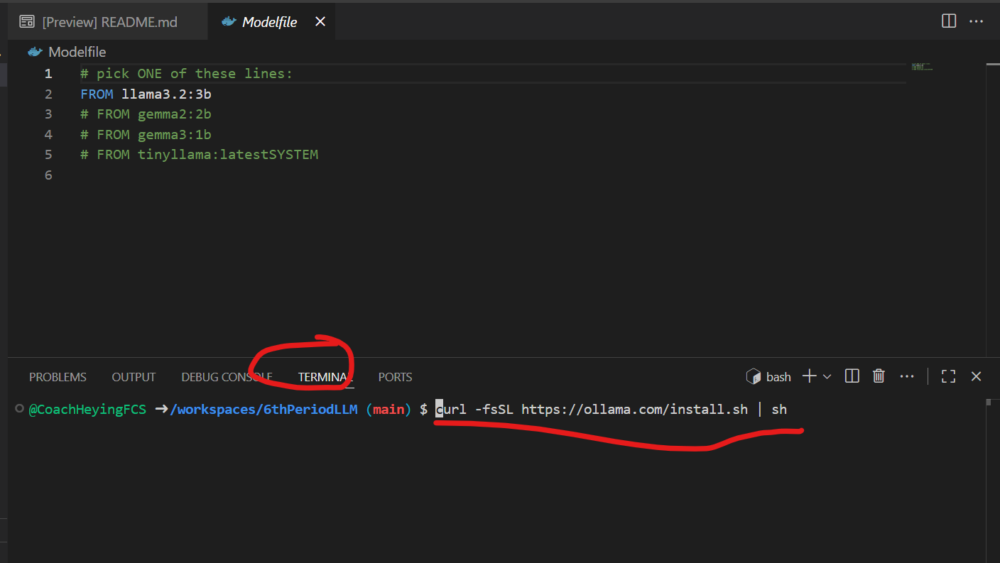
  - You only have to do this step once when you make your codespace. After it is installed, you can come back and start from step 5 to set up an individual LLM.
- Start the server:
  - ollama serve
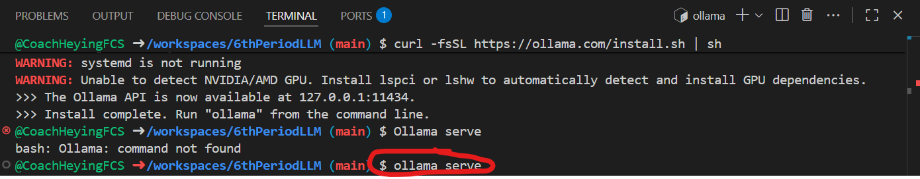
  - Keep this terminal running in the background and open a new one
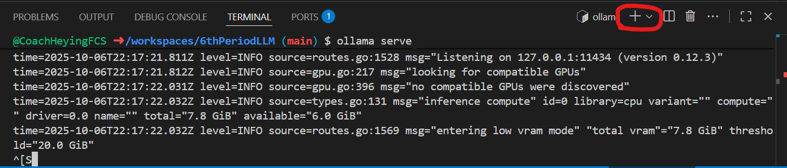
- Generate your model
  - Generate your model:
  - ollama create test-llm -f Modelfile
  - Red text can be replaced with anything you want. It is a file name.
  - Blue text must match the name of the file in your codespace.
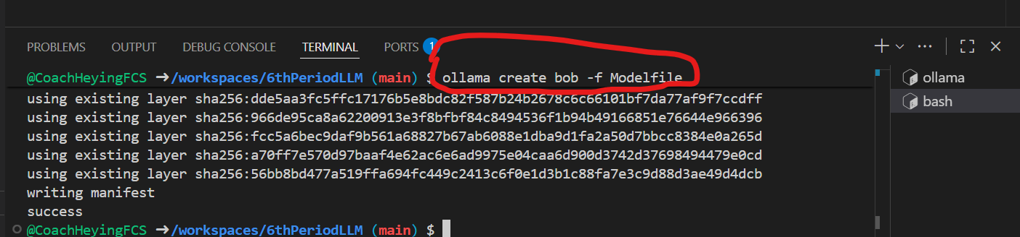
- Run your model to chat with your LLM
  - ollama run test-llm
  - Red text must match the name of the LLM file you just created
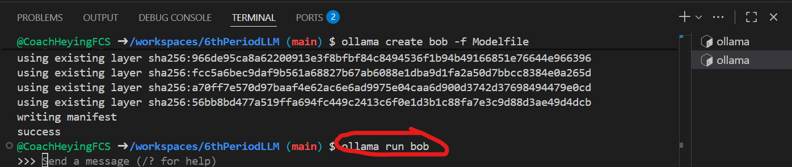
- Helpful commands while chatting:
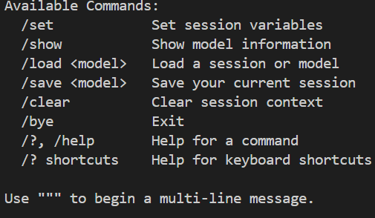
- Additional helpful commands that can be run in a new terminal or after you stop chatting with your LLM
  - pkill ollama
    - Stops the ollama server
  - ollama ps
    - Shows active LLMs and some information about them
  - ollama stop <model-name>
    - Removes a model from actively running

